New Photosensitizers for the Hydrogen Evolution Reaction and Photovoltaics.
Garry S. Hanan
Département de chimie, Université de Montréal, Montréal, Québec H2V 0B3, Canada
e-mail: garry.hanan@umontreal.ca
Rising global population and increased CO₂ levels in the atmosphere have focused attention on developing alternative and widely available carbon-free energy sources.^{1,2} Our research focuses on harnessing the unique properties of excited states in metal complexes to drive self-assembly processes and develop innovative energy applications. By leveraging the photophysical and photochemical behaviors of these complexes, we explore how light-induced excitations can be utilized to control molecular organization and energy transfer at the nanoscale. The parallels with Natural Photosynthesis are evident: light energy is captured by self-assembled Light Harvesting Complexes and is channeled to a reaction centre which induces electron transfer and the eventual production of chemical energy.³
Our approach involves the synthesis of polypyridyl-based metal complexes, which are known for their stability and tunable electronic properties (Fig.). By manipulating the excited states of these complexes, we develop photoactive molecular devices capable of storing and transferring electrons, offering insights into the design of next-generation photosensitizers for chemical energy production.⁴ Moving from second- and third-row transition metal ions to the first row, we explore energy applications of these abundant, inexpensive and relatively non-toxic metal ions.⁵
The application of these complexes in the Hydrogen Evolution Reaction (HER) and preliminary photovoltaic results will be presented.
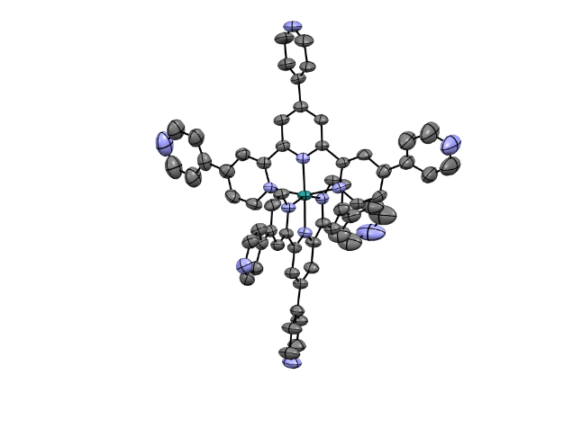
Figure: Tris-4’’’-pyridyl-2,2’ :6’,2’’-terpyridine and its Ru(II) complex.⁴
References
- https://ourworldindata.org/world-population-growth (01-07-2026).
- https://www.iea.org/world (01-07-2026).
- V. Balzani, A. Credi, M. Venturi, Chem Sus Chem 2008, 1, 26.
- G. M. Mercier, E. Rousset, I. Oubaha, K. Bandyopadhyay, A. K. Pal, I. Ciofini, L.-M. Chamoreau, V. Marvaud, G. S. Hanan, Chem. Commun. 2025 61 (77), 14911-14914.
- A. Saha, G. Turner, M. Cibian, S. Serroni, S. Genovese, S. Campagna, G. S. Hanan, F. Nastasi, submitted for publication.

Garry Hanan is professor in the Department of Chemistry at the Université de Montréal, where he leads the Green Energy Group and is a member of the Centre for Green Chemistry and Catalysis. He earned his B. Sc. from the University of Winnipeg, Canada, his PhD from Université Louis Pasteur in Strasbourg, France, under the supervision of Jean-Marie Lehn and subsequently conducted postdoctoral studies in Germany with Manfred T. Reetz and in Italy with Vincenzo Balzani and Sebastiano Campagna. Professor Hanan started his independent career at the University of Waterloo (Canada) and moved to the Université de Montréal in 2002.
His research focuses on the design and synthesis of supramolecular photocatalysts capable of harvesting solar energy to drive chemical transformations, most notably the photoproduction of fuels via water-splitting (producing H₂) and CO₂ reduction.
He has received numerous distinctions, including awards from IUPAC and NSERC, highlighting his contributions to sustainable chemistry and molecular materials science. He also actively promotes international student exchange.

